PLAY FAIR CIPHER

**Problem Statement:**

To encrypt a given text to Play fair cipher with key. Decrypt the given text with key and without key.

**Encryption:**

The input text and key is taken as input.The input key must not have any duplicates.The input text is formatted by converting it to upper case and removing spaces.The formatted string is send to the function Pair which pairs the text as an array of two characters,this array is called messagePair.If there are 2 repeating characters side by side Ex- SSA then a X is used to pair with one of the repeating characters,so it becomes SX and SA.If the length of the text in odd then a X is append at the end to make pairing possible.The function is shown below:

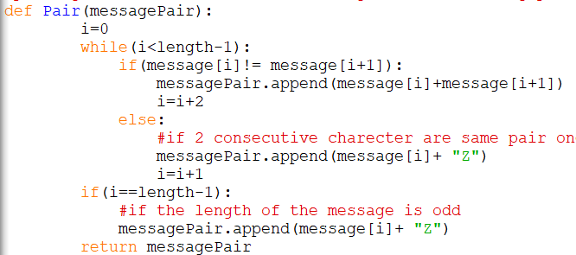

The next step is to make a 5X5 matrix which contains the key as the first few elements and the remaining alphabets as the rest of the elements.We make an array called alpha which contains all alphabets except J so that we have 25 alphabets to fill in the 5X5 array,We fill the elements row wise,first the key is inserted and then the remaining alphabets in order,this is done by the function fill which returns the 5X5 matrix and the updated alpha(without key elements).The function is shown below:

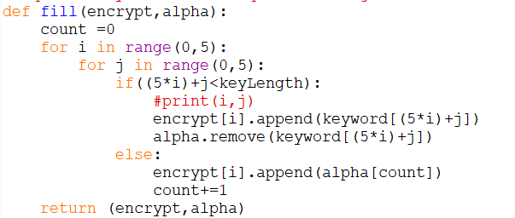

The next step is to get the index of the messagePair elements in the 5X5 matrix.Since the each elements in messagePair is a pair of 2 characters we will have get index of each of those characters in the pair.The index has been considered as row and column position of the individual characters in the 5X5 array we store the index of both the characters in a pair as a 4 element tuple and store this tuple in a list called index.This is done by the function getIndex which return the index.

The function is shown below:

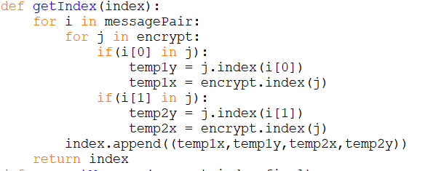

The final step is to encrypt, now we consider the 5X5 matrix and consider each pair the characters of the pair can be in:

1. Same row:Each character in the pair is encrypted as the next the character in that row with wrap around.
2. Same Column : Each character in the pair is encrypted as the next the character in that Column with wrap around.
3. Different Row and Column:If they lie on different rows and columns they form a rectangle and they lie on the diagonal ,change them to the values of the other diagonal pair.

This is done by the function encryptMessage which uses the 5X5 matrix,index array to get the

The function is shown below:

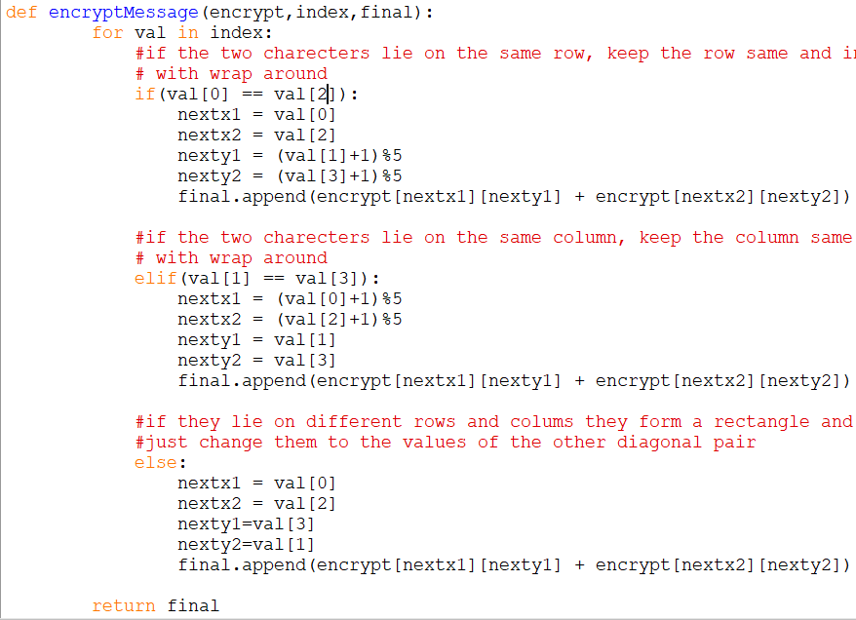

final is an array of string which when passed to join function results in the encrypted string.

**Decryption:**

In decryption we follow similar procedure we generate the 5X5 matrix with the key using the fill function shown before.

We then get then convert the decrypted text in an array of pairs similar, to what we did to the with the text in encryption, using function messagePair shown before.

Now we get the index array for this array of pairs using getIndex function shown before.

Finally The decryptMessage function uses the 5X5 matrix and the index array return an array of pairs of characters.This is done by applying the reverse operations of what was done in encryptMessage.

1.So if characters of the pairs are on the same row they are decrypted as the previous character in that row.

2.If characters of the pairs are on the same columns they are decrypted as the previous character in that column.

3.If they lie on different rows and columns,It is same as the step 3 of encryption.

The function decryptMessage is shown below:

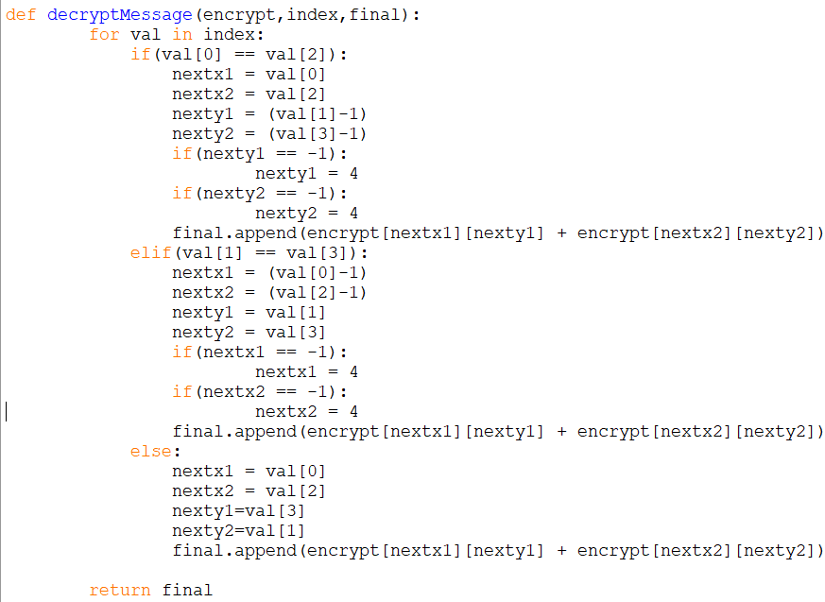

Before joining the array of pairs(final) we have to remove any possible X we would have added during encryption,this is done by the removeX function shown below:

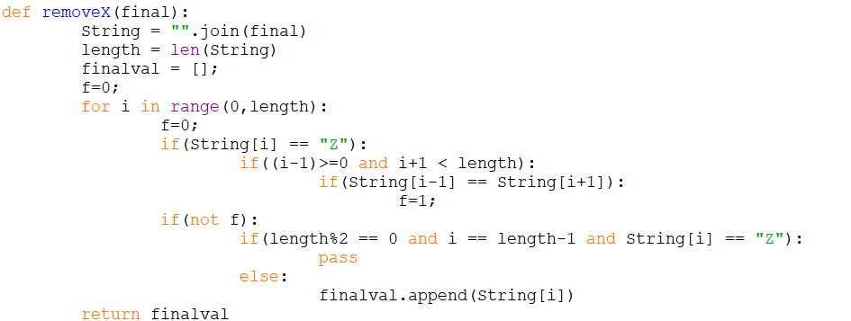

The function returns an array of string which make into a single string using the join function.The final decrypted string is achieved using the segment function imported from the module wordsegment.